**SUMMARY:-**

This idea emerged in my mind when I came across students posting on social media regarding the required carpool to their work place. So I decided what if there is one common place just for the carpool It would be one website one centralized place based of their location they can take carpool.

There would be different roles in the website, one who wants to provide their cars for pooling, one who wants to use the car pool, and the admin. This carpooling will have individuals help them sign in and I will have our own tie-up and that car will be used for carpooling.

**FUNCTIONALITY:-**

In my project I have implemented Velocity, Interceptor, Validator, Login, Signup, Mail API, File-upload.

USER:- User have option to post the car for sharing which includes all the details right from departure to destination and also includes information about the car and photo of the car. User can also see the posted car post of that particular user. User can also reply regarding confirmation/rejection of the request send by the user.

CUSTOMER:- Customer have the option to view all the cars posted by all the user. User also have the option to search car on the basis of departure and destination. Once customer want that car for sharing according to his/her convenience than he/she can request the owner of the car.

SCREENSHOT:-

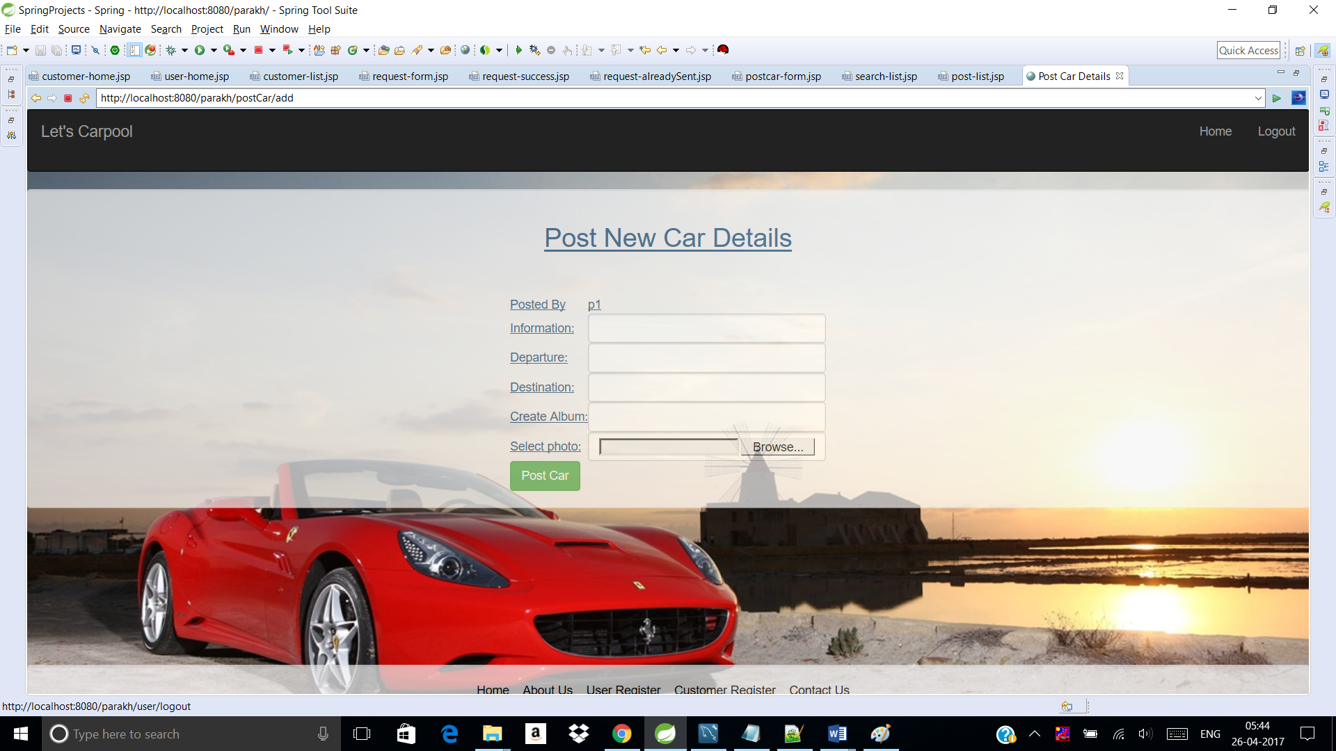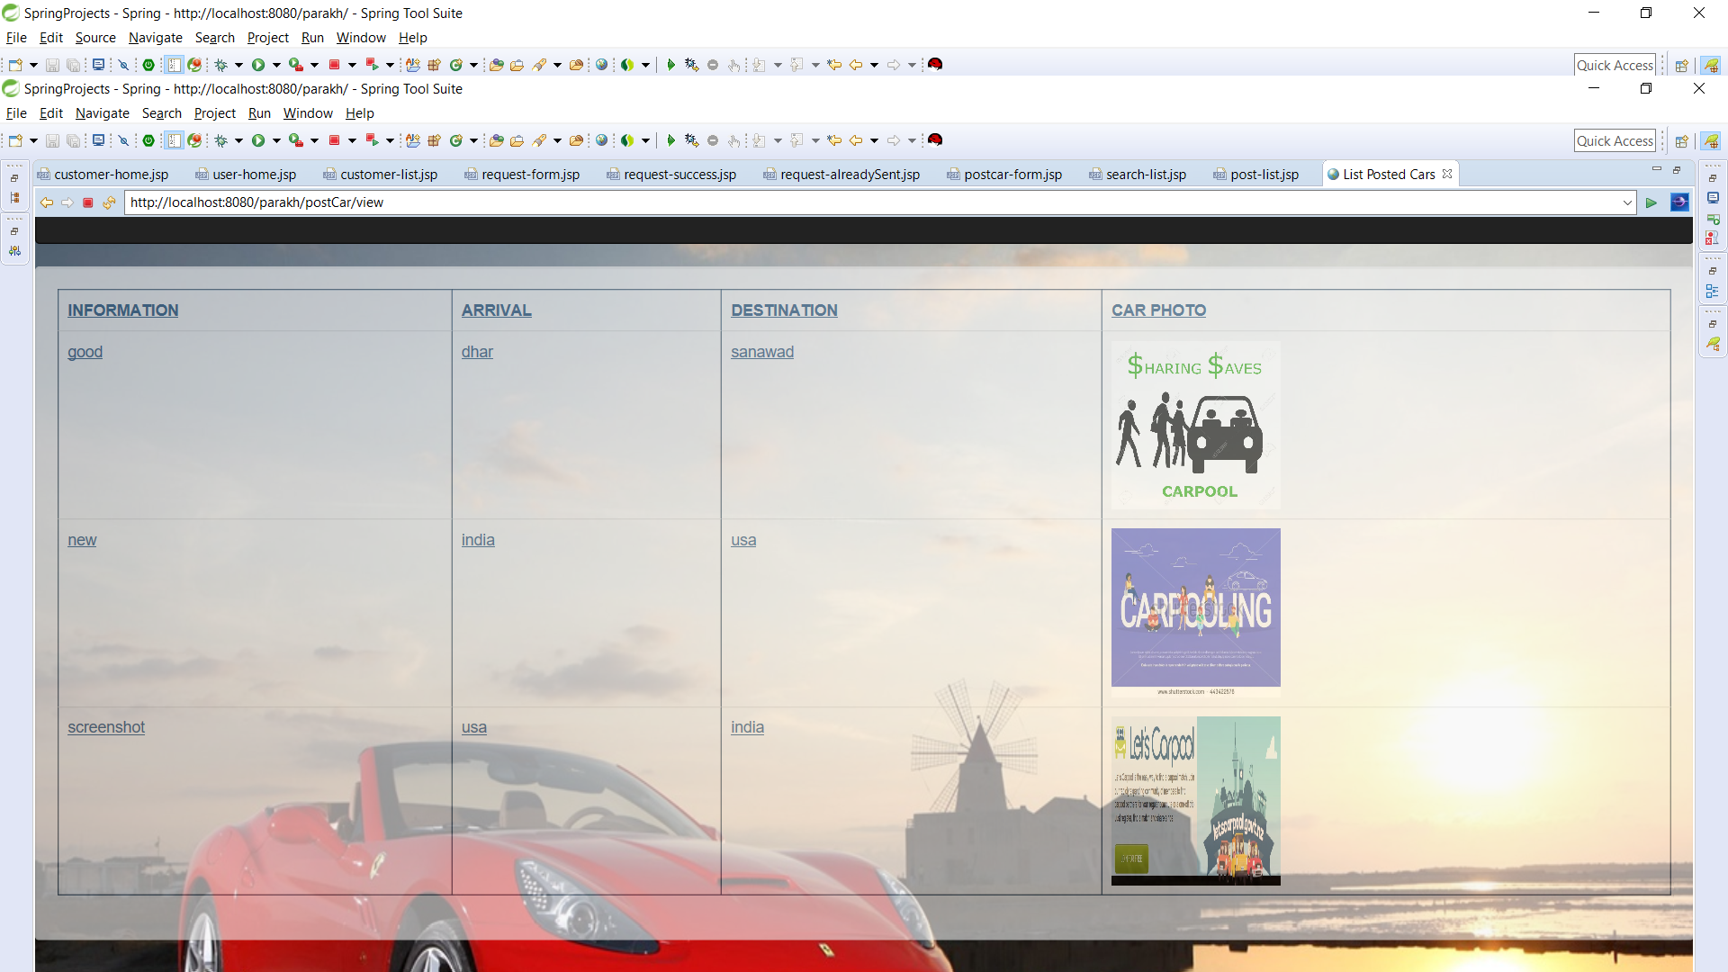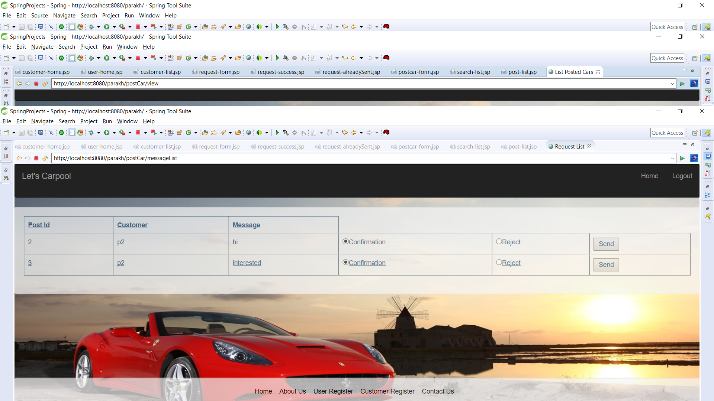

CONTROLLER:-

1)UserController:-

**package** com.parakh.parakh;

**import** javax.servlet.http.HttpServletRequest;

**import** javax.servlet.http.HttpSession;

**import** org.springframework.beans.factory.annotation.Autowired;

**import** org.springframework.beans.factory.annotation.Qualifier;

**import** org.springframework.stereotype.Controller;

**import** org.springframework.validation.BindingResult;

**import** org.springframework.web.bind.WebDataBinder;

**import** org.springframework.web.bind.annotation.InitBinder;

**import** org.springframework.web.bind.annotation.ModelAttribute;

**import** org.springframework.web.bind.annotation.RequestMapping;

**import** org.springframework.web.bind.annotation.RequestMethod;

**import** org.springframework.web.servlet.ModelAndView;

**import** com.parakh.parakh.dao.UserDAO;

**import** com.parakh.parakh.exception.UserException;

**import** com.parakh.parakh.pojo.Customer;

**import** com.parakh.parakh.pojo.User;

**import** com.parakh.parakh.validator.CustomerValidator;

**import** com.parakh.parakh.validator.UserValidator;

@Controller

@RequestMapping("/user/*")

**public** **class** UserController {

@Autowired

@Qualifier("userDao")

UserDAO userDao;

@Autowired

@Qualifier("userValidator")

UserValidator userValidator;

@Autowired

@Qualifier("customerValidator")

CustomerValidator customerValidator;

@InitBinder("user")

**private** **void** initBinder(WebDataBinder binder) {

binder.setValidator(userValidator);

}

@InitBinder("customer")

**private** **void** initBinder1(WebDataBinder binder) {

binder.setValidator(customerValidator);

}

@RequestMapping(value = "/", method = RequestMethod.***GET***)

**protected** String goToUserHome(HttpServletRequest request) **throws** Exception {

**return** "user-home";

}

@RequestMapping(value = "/user/login", method = RequestMethod.***POST***)

**protected** String loginUser(HttpServletRequest request) **throws** Exception {

HttpSession session = (HttpSession) request.getSession();

//userValidator.validate(user, result);

**try** {

System.***out***.print("loginUser");

User u = userDao.get(request.getParameter("username"), request.getParameter("password"));

Customer c = userDao.getCustomer(request.getParameter("username"), request.getParameter("password"));

**if**(u == **null** && c == **null**){

System.***out***.println("UserName/Password does not exist");

session.setAttribute("errorMessage", "UserName/Password does not exist");

**return** "error";

}

**if**(c == **null**){

**if**(u.getStatus().equalsIgnoreCase("user")){

session.setAttribute("user", u);

**return** "user-home";

}

}

**if**(u == **null**){

**if**(c.getStatus().equalsIgnoreCase("customer")){

request.getSession().setAttribute("customer", c);

**return** "customer-home";

}

}

**return** **null**;

} **catch** (UserException e) {

System.***out***.println("Exception: " + e.getMessage());

session.setAttribute("errorMessage", "error while login");

**return** "error";

}

}

@RequestMapping(value = "/user/register", method = RequestMethod.***GET***)

**protected** ModelAndView registerUser() **throws** Exception {

System.***out***.print("registerUser");

**return** **new** ModelAndView("register-user", "user", **new** User());

}

@RequestMapping(value = "/user/register", method = RequestMethod.***POST***)

**protected** ModelAndView registerNewUser(HttpServletRequest request, @ModelAttribute("user") User user, BindingResult result) **throws** Exception {

userValidator.validate(user, result);

**if** (result.hasErrors()) {

**return** **new** ModelAndView("register-user", "user", user);

}

**try** {

System.***out***.print("registerNewUser");

User u = userDao.register(user);

request.getSession().setAttribute("user", u);

**return** **new** ModelAndView("user-home", "user", u);

} **catch** (UserException e) {

System.***out***.println("Exception: " + e.getMessage());

**return** **new** ModelAndView("error", "errorMessage", "error while login");

}

}

//customer signup

@RequestMapping(value = "/user/registerCustomer", method = RequestMethod.***GET***)

**protected** ModelAndView registerCustomer() **throws** Exception {

System.***out***.print("registerCustomer");

**return** **new** ModelAndView("register-customer", "customer", **new** Customer());

}

@RequestMapping(value = "/user/registerCustomer", method = RequestMethod.***POST***)

**protected** ModelAndView registerNewCustomer(HttpServletRequest request, @ModelAttribute("customer") Customer customer, BindingResult result) **throws** Exception {

customerValidator.validate(customer, result);

**if** (result.hasErrors()) {

**return** **new** ModelAndView("register-customer", "customer", customer);

}

**try** {

System.***out***.print("registerNewCustomer");

Customer c = userDao.registerCustomer(customer);

request.getSession().setAttribute("customer", c);

**return** **new** ModelAndView("customer-home", "customer", c);

} **catch** (UserException e) {

System.***out***.println("Exception: " + e.getMessage());

**return** **new** ModelAndView("error", "errorMessage", "error while login");

}

}

@RequestMapping(value = "/user/login", method = RequestMethod.***GET***)

**protected** ModelAndView homeCustomer() **throws** Exception {

**return** **new** ModelAndView("customer-home");

}

//logout

@RequestMapping(value = "/user/logout", method = RequestMethod.***GET***)

**protected** String logout(HttpServletRequest request) **throws** Exception {

request.getSession().invalidate();

//System.out.println("inside Logout----------------");

**return** "redirect: /parakh";

}

}

2)PostController:-

**package** com.parakh.parakh;

**import** java.io.File;

**import** java.io.IOException;

**import** java.util.List;

**import** javax.servlet.ServletContext;

**import** javax.servlet.http.HttpServletRequest;

**import** javax.servlet.http.HttpSession;

**import** org.springframework.beans.factory.annotation.Autowired;

**import** org.springframework.beans.factory.annotation.Qualifier;

**import** org.springframework.mail.MailSender;

**import** org.springframework.mail.SimpleMailMessage;

//import org.springframework.mail.MailSender;

**import** org.springframework.stereotype.Controller;

**import** org.springframework.validation.BindingResult;

**import** org.springframework.web.bind.annotation.ModelAttribute;

**import** org.springframework.web.bind.annotation.RequestMapping;

**import** org.springframework.web.bind.annotation.RequestMethod;

**import** org.springframework.web.multipart.commons.CommonsMultipartFile;

**import** org.springframework.web.servlet.ModelAndView;

**import** com.parakh.parakh.dao.PostDAO;

**import** com.parakh.parakh.dao.UserDAO;

**import** com.parakh.parakh.exception.PostException;

**import** com.parakh.parakh.exception.UserException;

**import** com.parakh.parakh.pojo.Customer;

**import** com.parakh.parakh.pojo.PostCar;

**import** com.parakh.parakh.pojo.Request;

**import** com.parakh.parakh.pojo.User;

**import** com.parakh.parakh.validator.PostValidator;

@Controller

@RequestMapping("/postCar/*")

**public** **class** PostController {

@Autowired

@Qualifier("postDao")

PostDAO postDao;

@Autowired

@Qualifier("userDao")

UserDAO userDao;

@Autowired

@Qualifier("mailSender")

**private** MailSender mailSender;

@Autowired

@Qualifier("postValidator")

**private** PostValidator postValidator;

@Autowired

ServletContext servletContext;

@RequestMapping(value="/postCar/add", method = RequestMethod.***GET***)

**public** ModelAndView initializeForm(HttpServletRequest request) **throws** Exception {

//return new ModelAndView("postcar-form", "postCar", new PostCar());

ModelAndView mv = **new** ModelAndView();

mv.addObject("postCar", **new** PostCar());

mv.setViewName("postcar-form");

**return** mv;

}

@RequestMapping(value = "/postCar/add", method = RequestMethod.***POST***)

**public** ModelAndView addCategory(HttpServletRequest request,@ModelAttribute("postCar") PostCar postCar, BindingResult result) **throws** Exception {

postValidator.validate(postCar, result);

**if** (result.hasErrors()) {

**return** **new** ModelAndView("postcar-form", "postCar", postCar);

}

// try {

// //HttpSession session = request.getSession();

// System.out.println("grgre frewrf "+ postCar.getPostedBy());

// User u = userDao.get(postCar.getPostedBy());

// postCar.setUser(u);

// postCar = postDao.create(postCar);

//

// return new ModelAndView("post-success", "postCar", postCar);

//

// } catch (PostException e) {

// System.out.println(e.getMessage());

// return new ModelAndView("error", "errorMessage", "error while login");

// }

//

//

// }

//System.out.println(request.getParameter("fileName")+"----------------------------------------------------");

**try** {

**if** (postCar.getFileName().trim() != "" || postCar.getFileName() != **null**) {

File directory;

String check = File.***separator***; // Checking if system is linux

// based or windows based by

// checking seprator used.

String path = **null**;

**if** (check.equalsIgnoreCase("\\")) {

path = servletContext.getRealPath("resources").replace("build\\", ""); // gives real path as Lab9/build/web/

// so we need to replace build in the path

}

**if** (check.equalsIgnoreCase("/")) {

path = servletContext.getRealPath("").replace("build/", "");

path += "/"; // Adding trailing slash for Mac systems.

}

directory = **new** File(path + "\\" + postCar.getFileName());

**boolean** temp = directory.exists();

**if** (!temp) {

temp = directory.mkdir();

}

**if** (temp) {

// // We need to transfer to a file

// CommonsMultipartFile photoInMemory = postCar.getPhoto();

//

// String fileName = photoInMemory.getOriginalFilename();

// // could generate file names as well

//

// File localFile = new File(directory.getPath(), fileName);

//

// // move the file from memory to the file

//

// photoInMemory.transferTo(localFile);

File localFile;

CommonsMultipartFile photoInMemory = postCar.getPhoto();

String name = photoInMemory.getOriginalFilename();

localFile =**new** File("C:\\webtools\\images",name);

photoInMemory.transferTo(localFile);

postCar.setFileName(localFile.getPath());

// System.out.println("File is stored at" + localFile.getPath());

// System.out.print("registerNewUser");

// User u = userDao.register(user);

User u = userDao.get(postCar.getPostedBy());

postCar.setUser(u);

postCar = postDao.create(postCar);

} **else** {

System.***out***.println("Failed to create directory!");

}

}

} **catch** (IllegalStateException e) {

System.***out***.println("*** IllegalStateException: " + e.getMessage());

} **catch** (IOException e) {

// **TODO** Auto-generated catch block

System.***out***.println("*** IOException: " + e.getMessage());

} **catch** (PostException e) {

// **TODO** Auto-generated catch block

e.printStackTrace();

System.***out***.println(e.getMessage());

**return** **new** ModelAndView("error", "errorMessage", "error while login");

}

**return** **new** ModelAndView("post-success", "postCar", postCar);

}

@RequestMapping(value = "/postCar/view", method = RequestMethod.***GET***)

**public** ModelAndView viewUser(HttpServletRequest request) **throws** Exception {

**try** {

HttpSession session = request.getSession();

User u = (User) session.getAttribute("user");

List<PostCar> postCar = postDao.specificList(u.getPersonId());

**return** **new** ModelAndView("post-list", "postCar", postCar);

} **catch** (PostException e) {

System.***out***.println(e.getMessage());

**return** **new** ModelAndView("error", "errorMessage", "error while login");

}

}

@RequestMapping(value = "/postCar/delete", method = RequestMethod.***POST***)

**public** ModelAndView deleteCategory(HttpServletRequest request) **throws** Exception {

**try** {

HttpSession session = request.getSession();

// System.out.println("grgre frewrf "+ postCar.getPostedBy());

// User u = userDao.get(postCar.getPostedBy());

// postCar.setUser(u);

// System.out.println("fsdgdb" + postCar.getDestinationTo());

**int** postId = Integer.*parseInt*(request.getParameter("delete"));

System.***out***.println(postId+"======================================================================");

//PostCar postCar = postDao.get(postId);

User u = (User)session.getAttribute("user");

List<PostCar> postCarList = postDao.specificList(u.getPersonId());

**for**(PostCar postCar : postCarList)

{

postCar = postDao.get(postId);

postDao.delete(postCar);

}

} **catch** (PostException e) {

System.***out***.println(e.getMessage());

**return** **new** ModelAndView("error", "errorMessage", "error while login");

}

**return** **new** ModelAndView("post-delete");

}

@RequestMapping(value = "/postCar/request", method = RequestMethod.***GET***)

**public** ModelAndView viewCustomer(HttpServletRequest request) **throws** Exception {

**try** {

HttpSession session = request.getSession();

User u = (User) session.getAttribute("user");

List<PostCar> postCar = postDao.list();

**return** **new** ModelAndView("customer-list", "postCar", postCar);

} **catch** (PostException e) {

System.***out***.println(e.getMessage());

**return** **new** ModelAndView("error", "errorMessage", "error while login");

}

}

@RequestMapping(value="/postCar/search", method = RequestMethod.***GET***)

**public** ModelAndView searchCar(HttpServletRequest request) **throws** Exception {

//return new ModelAndView("postcar-form", "postCar", new PostCar());

ModelAndView mv = **new** ModelAndView();

mv.addObject("postCar", **new** PostCar());

mv.setViewName("searchCar-list");

**return** mv;

}

@RequestMapping(value = "/postCar/search", method = RequestMethod.***POST***)

**public** ModelAndView searchCar(HttpServletRequest request,@ModelAttribute("postCar") PostCar postCar, BindingResult result) **throws** Exception {

postValidator.validate(postCar, result);

**if** (result.hasErrors()) {

**return** **new** ModelAndView("searchCar-list", "postCar", postCar);

}

**try** {

//HttpSession session = request.getSession();

String arrival = request.getParameter("arrivalFrom");

String destination = request.getParameter("destinationTo");

System.***out***.println(arrival +"fsghj");

System.***out***.println(destination +"fsghfefefefegej");

List<PostCar> searchlist= postDao.search(arrival, destination);

**for**(PostCar ps : searchlist){

System.***out***.println(ps +"fsghjfefee");

}

**return** **new** ModelAndView("search-list", "searchlist", searchlist);

} **catch** (PostException e) {

System.***out***.println(e.getMessage());

**return** **new** ModelAndView("error", "errorMessage", "Sorry there is error in finding your search result");

}

}

//message

@RequestMapping(value="/postCar/requestMessage", method = RequestMethod.***GET***)

**public** ModelAndView sendRequest(HttpServletRequest request) **throws** Exception {

//return new ModelAndView("postcar-form", "postCar", new PostCar());

Customer customer = (Customer)request.getSession().getAttribute("customer");

**int** personId = customer.getPersonId();

**int** postId = Integer.*parseInt*(request.getParameter("request"));

PostCar postCar = postDao.get(postId);

List<Request> messageAllList = postDao.messageAllList();

ModelAndView mv = **new** ModelAndView();

**for**(Request message : messageAllList)

{

**if**(message.getCustomer().getPersonId() == personId && message.getPostCar().getPostId() == postId)

{

mv.setViewName("request-alreadySent");

**return** mv;

}

}

mv.addObject("postCar", postCar);

mv.addObject("request", **new** Request());

mv.setViewName("request-form");

**return** mv;

}

@RequestMapping(value = "/postCar/requestMessage", method = RequestMethod.***POST***)

**public** ModelAndView sendRequest(HttpServletRequest request, Request requestMessage, BindingResult result) **throws** Exception {

**try** {

String message = request.getParameter("message");

**int** postId = Integer.*parseInt*(request.getParameter("send"));

PostCar postCar = postDao.get(postId);

//postCar.getPostId();

Customer customer = (Customer)request.getSession().getAttribute("customer");

//System.out.println(customer.getFirstName() + "hi POsted car here");

//requestMessage.setMessage(message);

//System.out.println(message + "hi message");

//requestMessage.setPostCar(postCar);

//System.out.println(postCar + "hi POsted car here");

//requestMessage.setCustomer(customer);

//System.out.println(customer + "hi customer here");

postDao.storeMessage(message, postCar, customer);

// SimpleMailMessage email = new SimpleMailMessage();

// email.setTo("parakh.mahajan@gmail.com");

// email.setSubject("CarPost Application");

// email.setText("Hi Thanks for applying to Confirm ");

// mailSender.send(email);

ModelAndView mv = **new** ModelAndView();

mv.addObject("postCar", postCar);

mv.addObject("message", requestMessage);

mv.setViewName("request-success");

**return** mv;

} **catch** (PostException e) {

System.***out***.println(e.getMessage());

**return** **new** ModelAndView("error", "errorMessage", "error while login");

}

}

//getting list of request list

@RequestMapping(value="/postCar/messageList", method = RequestMethod.***GET***)

**public** ModelAndView requestList(HttpServletRequest request) **throws** Exception {

//return new ModelAndView("postcar-form", "postCar", new PostCar());

User u = (User)request.getSession().getAttribute("user");

**int** personId = u.getPersonId();

List<Request> messageList = postDao.messageList(personId);

ModelAndView mv = **new** ModelAndView();

mv.addObject("messageList", messageList);

mv.setViewName("message-list");

**return** mv;

}

@RequestMapping(value = "/postCar/mail", method = RequestMethod.***POST***)

**public** ModelAndView seacrhUser(HttpServletRequest request) **throws** UserException {

String messageId = request.getParameter("messageId");

String key = request.getParameter(messageId);

String personId = request.getParameter("send");

**try** {

Customer c = userDao.getCustomer(personId);

String customerEmail = c.getEmail();

**if**(key.equalsIgnoreCase("confirmation"))

{

SimpleMailMessage email = **new** SimpleMailMessage();

email.setTo("mahajan.pa@husky.neu.edu");

email.setSubject("CarPost Application");

email.setText("Hi Thanks for applying to Confirm ");

mailSender.send(email);

**return** **new** ModelAndView("user-home");

}

**else**

{

SimpleMailMessage email = **new** SimpleMailMessage();

email.setTo(customerEmail);

email.setSubject("JobBoard Application");

email.setText("Hi Thanks for applying to Rejected ");

mailSender.send(email);

**return** **new** ModelAndView("user-home");

}

} **catch** (UserException e) {

// **TODO** Auto-generated catch block

e.printStackTrace();

**return** **new** ModelAndView("error", "errorMessage", "error while sending mail");

}

//User u =get method from dao(persid)

//var sendemail = u.getEmail.id;

}

}